Registration form

1)create new folder

2)create new file -index.html

4)make div tag <div class="container"></div>

//group and style the content inside.

3)heading

<h3>form</h3>

4)form tag

Table tr td

Label for

Input -type id name

P id

* <td> <label for="name">Name</label></td>
* Type of Element: <td> is a table cell in HTML.
* Label Purpose: <label for="name"> creates a label for an input with the ID "name."
* Use Case: It's part of a form, making it clear that the input with ID "name" is for the user's name.

<form>

<table>

<tr>

<td> <label for="name">Name</label></td>

<td><input type="text" id="name" name="name" </td>

<td><p id="name_err"></p></td>

</tr>

Td label

Td select id name

Option value selected disables

Placeholder text

Option value

Td p id err

<tr>

<td><label for="course" >course</label></td>

<td><select id="course" name="course">

<option value="" selected disabled>

--Please choose an course--

</option>

<option value="dac">DAC</option>

<option value="dbda">DBDA</option>

<option value="cse">CSE</option>

</select>

</td>

<td><p id="course_err"</td>

</tr>



This HTML code creates a table cell that spans two columns and contains a "Submit" button. The button is set up to trigger a JavaScript function called validateForm when clicked, likely for form validation before submission.

This HTML code represents a dropdown menu (select element) inside a table cell. Here's a breakdown:

1. **HTML Element:** `<td>` - This is a table cell.

2. **Dropdown Menu:** `<select id="course" name="course">` - This creates a dropdown menu with the ID "course" and the name "course."

3. **Default Option:**

```html

<option value="" selected disabled>

--Please choose a course--

</option>

```

- This is the default or placeholder option. It's not selectable and encourages the user to choose a valid option.

4. **Selectable Options:**

- `<option value="dac">DAC</option>`

- `<option value="dbda">DBDA</option>`

- `<option value="ditis">DITIS</option>`

- These are the actual selectable options in the dropdown, representing different courses (DAC, DBDA, DITIS).

In summary, this HTML code creates a table cell with a dropdown menu of courses, prompting the user to choose from a list that includes DAC, DBDA, and DITIS.

**Button**

Button type onclick

<tr>

<td colspan="2">

<button type="submit" onclick="validateForm(event)">Submit</button>

</td>

</tr>



**Data**

Div =>p

<div id="formdata">

<h2 id="title">data</h2>

<p id="iname"></p>

<p id="iemail"></p>

<p id="ipassword"></p>

<p id="icourse"></p>

</div>

**script**

<script src="index.js"></script>

**In index .js**

1)defines validateForm using arrow function=>takes event parameter (e).

The purpose is likely to validate a form when called.

2)

e.preventDefault();,

stops the usual(defaut) action that would occur when an event (like a form submission) happens, allowing you to edit what should happen instead.

3)let name=document.getElementById("name").value;

Ek variable main elemnt ke name se value extract karo

fetches the value entered in an HTML element with the ID "name" and assigns it to a variable named name.

4)console.log(name, email, password, course);

Print those extracted values in console for debug

5)let flag =true;

6)if(name===""||name===null){

document.getElementById("name_err").innerHTML="name is required";

flag=false;

}

flag=true

If empty null

getId(“name_err”).innerHtml(“req”)

Flag false;

Set flag to true initially. Then, it checks if the variable name is an empty string ("") or null.sets an error message inside an HTML element with the ID "name_err" and updates the flag to false. The error message indicates that the name is required.

7)

if(flag){

alert("succesfully registeres");

document.getElementById("title").innerHtml="Student deatils";

document.getElementById("iname").innerHTML="name :"+ name ;

document.getElementById("iemail").innerHTML= "email :"+email ;

document.getElementById("ipassword").innerHTML="password"+password;

document.getElementById("icourse").innerHTML= "Course: "+course;

}

If flag=>alert=>title=>iname

This code checks if a registration is successful (flag is true). If so:

* Show Alert:
  + Display an alert saying "Successfully registered!"
* Update HTML:
  + Change the title to "Student Details" and display the student's name.

8)

document.getElementById("name_err").innerHTML="";

This line of code empties the content of an HTML element with the ID "course_err".

4)make form tag

<form id ="registrationform" >

</form>

form element with the ID attribute set to "registrationForm". The onsubmit attribute is set to a JavaScript function validateForm(), which means that the function will be called when the form is submitted.

return validateForm() in onsubmit ensures that the form submission only proceeds if the validateForm() function returns true. If validateForm() returns false, the form submission is stopped, preventing the form from being submitted. This allows for client-side validation before the form is sent to the server.

5) <input type="text">



6)Name :<input type="text">

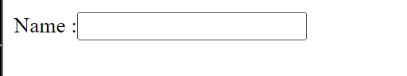

7)

Password:<input type="password" name="password" id="ps" required>

<span id="password error" class="error" ></span>

type= When the type is set to "password", the characters entered in the field are typically masked

id= use in css and js

Name = use for server to identify

required: Ensures that the user must enter a value in the password field before submitting the form.

Span with id and class = initilaaly empty but display error msg when validation fails

8) <button type="submit">Submit</button>

<button type="button" onclick="return validateForm(event)">Submit</button>

Remember type=”button “ and onclick and not onsubmit as submit se refresh hota h

8) <div id="formData"></div>

9)after div tag add script with src

<script src="script.js"></script>

Before title Add style

<link rel="stylesheet" href="styles.css">

* <link> Element: relationships between the current document and an external resource. In this case, it's used to link a stylesheet.
* rel="stylesheet" Attribute: relationship between the HTML document and the linked resource. stylesheet indicates that the linked resource is a stylesheet, which is used to style the HTML document.
* href="styles.css" Attribute: specifies the URL (or path) to the external resource. In this case, it's pointing to a CSS file named "styles.css" in the same directory as the HTML file.

**In css**

For whole body

1)Body{

}

2display: flex;

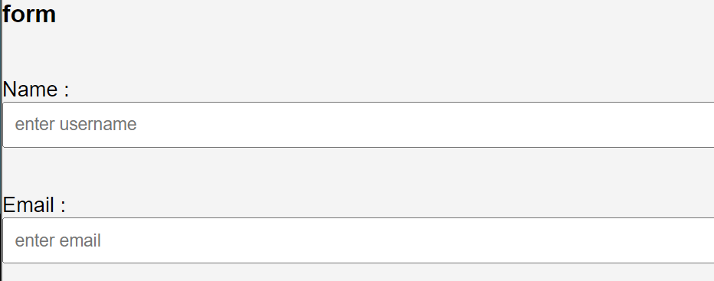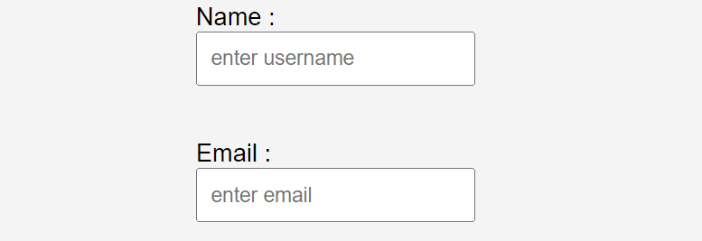

justify-content: center;

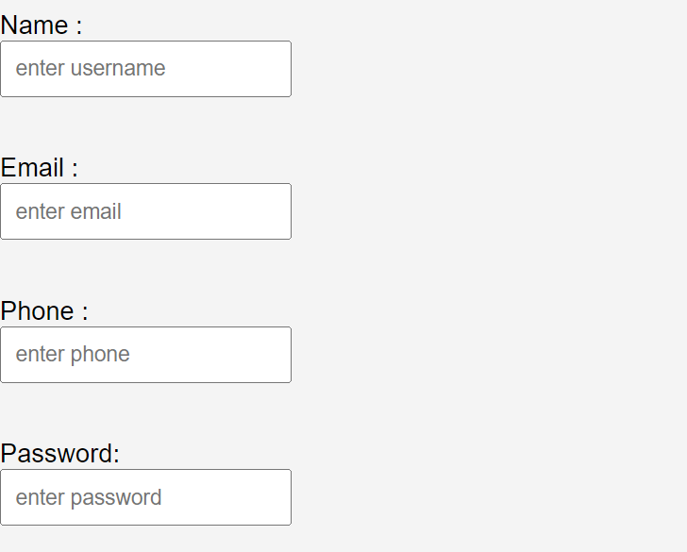

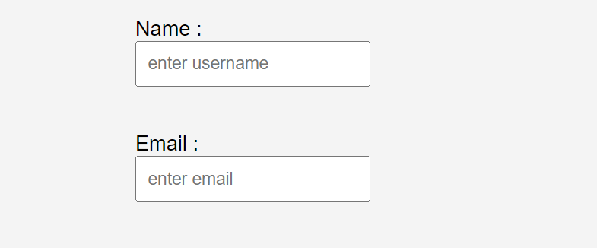

background-color: #f4f4f4;

2)for button

background-color: #4caf50;



3)for error

.error {

color: red;

font-size: 12px;

}

//color is for text color

4) for input

input {

padding: 8px;

margin-bottom: 16px;

}

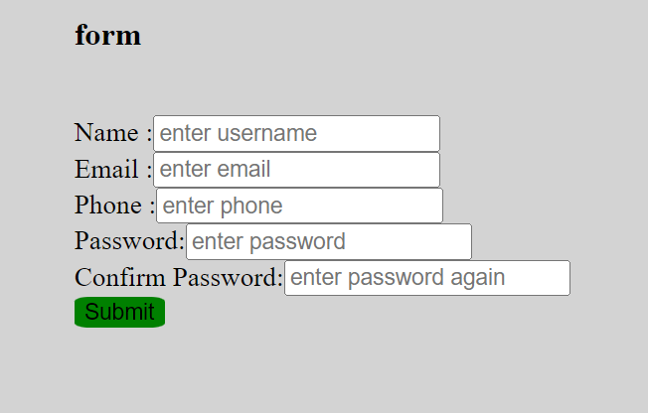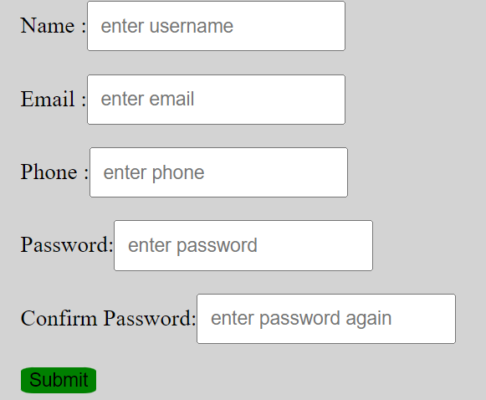

**In js**

1)make function for vlaidation

function validateForm(){

}

2)get form data

const name=document.getElementById("nm").value;

Retrieve elements whose id matches insibe bracket

Same do it for all

And also for form(to add event listener)

const form=document.getElementById("registrationform");

Not to show error msg(add span tag with id(html) and store in js by get

//get errors

const nm_err=document.getElementById("nm_err");

And in html

<div class="success" ></div>

<div>

<p id="name res"></p>

</div>

3)

Speciifc element pe jab (click,submit,mouseover) karoge tb function call hoga

If it's empty or null, event.preventDefault() is called, preventing the default form submission behavior.

4)

Now if we submit without writing username browser not reload

form.addEventListener("submit",function(event){

if(name.value=="" || name.value==null){

event.preventDefault();

nm_err.innerHTML("name is required");

}

})

Correct

nm_err.innerHTML="name is required";

**Problems**

Max

1. In head ,script tag
2. Write function
3. Declare var

The + sign before (document.getElementById("no1").value) is a shorthand way of converting a string to a number.

4)Certainly, let's simplify it:

1. **`document.getElementById("pr")`:**

- This part finds an area on the webpage with the ID "pr." In your case, it's a paragraph (`<p>`) element.

2. **`.innerHTML=`:**

- This is like opening a box to put something inside. In our case, we're going to put some text or HTML inside the "pr" box.

3. **`"Max No : "+`:**

- This is the beginning of what we want to put inside the "pr" box. It's a piece of text saying "Max No : ".

4. **`Math.max(n1, n2, n3)`:**

- This part calculates the maximum (largest) number among the three numbers `n1`, `n2`, and `n3`.

5. **`;`:**

- Think of this as closing the box. We're done putting things inside.

Putting it all together:

- We're finding the "pr" box on the webpage.

- We're putting a text inside that box. The text is "Max No : " followed by the maximum of three numbers (`n1`, `n2`, `n3`).

So, when this line is executed, the paragraph with the ID "pr" will show "Max No : " followed by the largest number among the three entered values.

5)The webpage begins with <body>.

* There are three input fields for entering numbers, each with unique IDs ("no1," "no2," "no3").
* A button with the ID "max" is created. Clicking it triggers the findMax function.
* An empty paragraph element with the ID "pr" is there to display the result of the maximum calculation.

1)in body

n1: <input type="text" id="no1"></br>

n2: <input type="text" id="no2"></br>

n3: <input type="text" id="no3"></br>

2) <button onsubmit="findmax()">max</button>

<button onclick="findmax()">max</button>

Replaced onsubmit with onclick on the <button> element since you are handling a button click, not a form submission.

3)in script

const n1=+(document.getElementById("no1").value);

const n2=+(document.getElementById("no2").value);

const n3=+(document.getElementById("no3").value);

4)const maxi=document.getElementById("prid").innerHTML="Max No : "+Math.max(n1,n2,n3);

Dont store this

document.getElementById("prid").innerHTML="Max No : "+Math.max(n1,n2,n3);

**Calculator**

1)n1:<input type="text" id="n1"><br>

n1:<input type="text" id="n2"><br>

2)<button onsubmit="calcadd()">+</button>

<button onclick="calcadd()" >+</button>

<button onclick="calcsub()">-</button>

<button onclick="calcdiv()">/</button>

<button onclick="calcmul()">*</button>

3) <button onclick="calc()">calculate</button>

Result :<input type="text" id ="res">

1. In script tag

const calcadd =()=>{ }

const calcadd =()=>{

const result=+(document.getElementById("n1").value) + +(document.getElementById("n2").value);

document.getElementById("res").value=result;

}

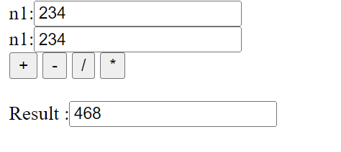

<script>

var n1 = parseInt(prompt("enter number"));

var n2 = parseInt(prompt("enter number2"));

var sym = prompt("enter");

if (sym == "+") document.write(n1 + n2);

else if (sym == "-") document.write(n1 - n2);

else if (sym == "/") document.write(n1 / n2);

else if (sym == "*") document.write(n1 * n2);

</script>

**How many times msg**

<script>

var msg = prompt("enter msg");

var num = prompt("enter nu");

for (i = 0; i <= num; i++) {

document.write(msg + " ");

}

</script>

**Even range**

**<script>**

**var n = prompt("enter numb");**

**for (i = 2; i <= n; i += 2) {**

**document.write(i);**

**}**

**</script>**